Arevalo, Mark Anthony A. March 20, 2016

Asaba, Hiroki M. S22

Deogracias, Nolan Matthew T.

Nablo, Juan Paolo J.

Paturo: Market and Customer Research Results

Paturo is for learners who are in need of guidance from a professional, PATURO is an online service that would provide learners the opportunity to interact with professionals in order to set a meet up and discuss about their fields of expertise. For certified professionals who would like to share their knowledge, PATURO is an online service that would enable a professional the chance to provide learners with their expertise for a certain fee. Unlike Online Tutoring Services (live) or tutoring centers, our product ensures quick and easy access to tutorial sessions provided by professionals, who are willing to meet up with learners who are eager to learn about their field.

A survey was conducted regarding the prototype of the service: Paturo. The respondents answered the survey after viewing the prototype’s video. Two types of research was implemented in the survey, this included: Market and New Customer research.

**Analysis:**

CUSTOMER RESEARCH:

Age: Respondents’ ages ranging from 14 to 21. Average is 18, meaning students from universities are interested.

1. What do you like most about our new service?

**Common response is that customers think that the product is new, unique, and easy to use.**

1. What changes would most improve our new service?

**Majority of the respondents answer that the Graphical User Interface (GUI) needs improvement.**

1. What do you like most about competing services currently available from other companies?

**Common responses are easier use and customer relations regarding the service.**

1. What changes would most improve competing services currently available from other companies?

**Majority answered none but there are still answers such as website design, customer service, payment method, etc.**

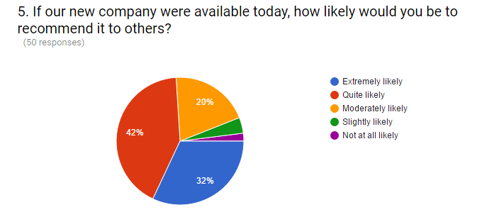

6. What would make you more likely to use our new service?

**Common responses were mobile application version for phones and gadgets, conveniency, affordable tutor rates, availability of tutors, and other payment methods.**

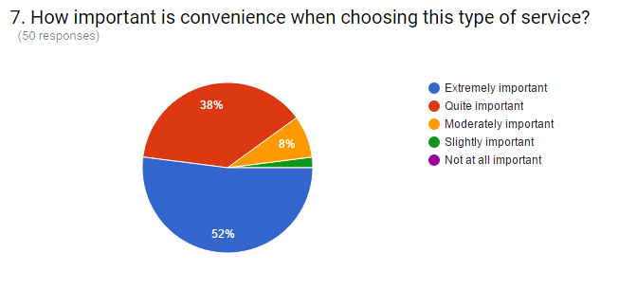

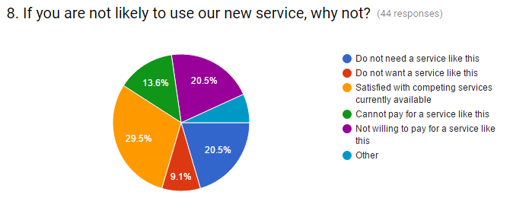

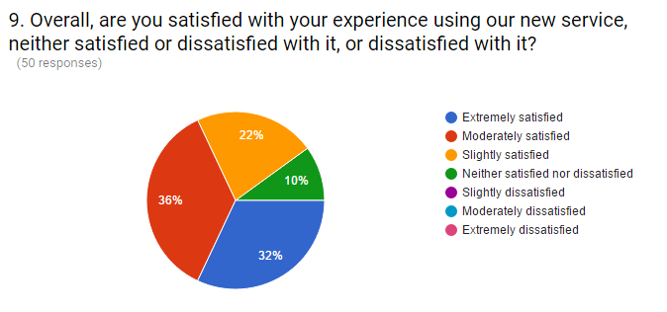

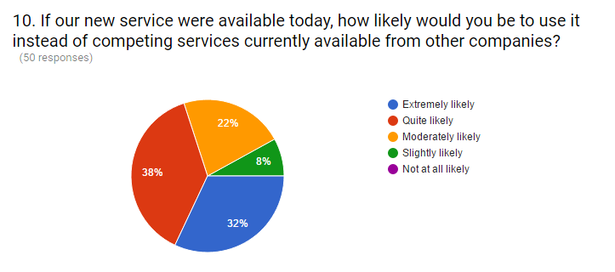

MARKET RESEARCH:

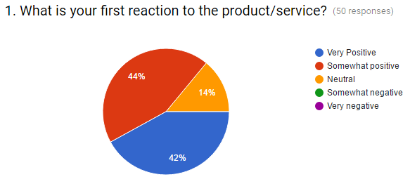

Based on the data above, the respondents’ first reaction to Paturo was mostly somewhat positive. While the very positive reaction is a close second. No one has given a negative response.

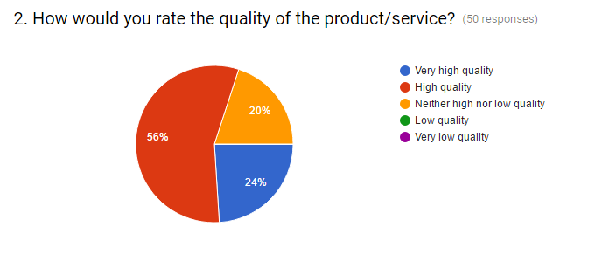

Based on the data above, the respondents have given a positive feedback. Most have answered that Paturo is of high quality while ‘very high quality’ was 24%. No one has answered a negative response.

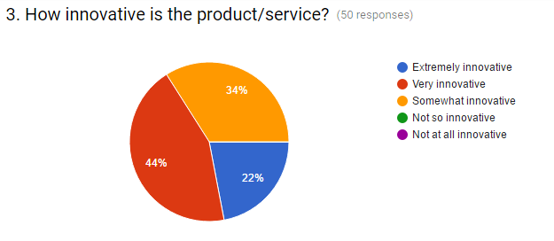

Based on the data above, 44% of the respondents have have that Paturo is very innovative while 34% find if somewhat innovative. Again, no one has found the service negative.

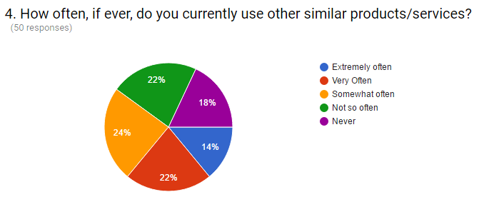

Based on the data above, the respondents have answered mixed options. Though ‘somewhat often’ leads the poll, it is not as significant compared to the other results.

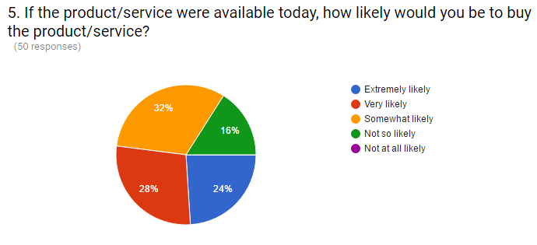

Based on the data above, most of the respondents would use the service. But 16% say that they are ‘not so likely’ to buy the service.

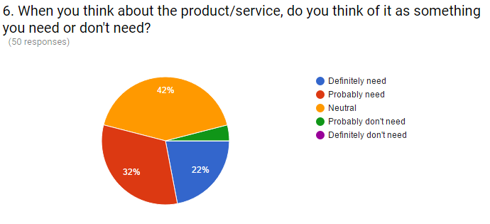

Based on the data above, the respondents are mostly neutral about this product being a need or not. Though only 4% of the respondents find it as not a need.

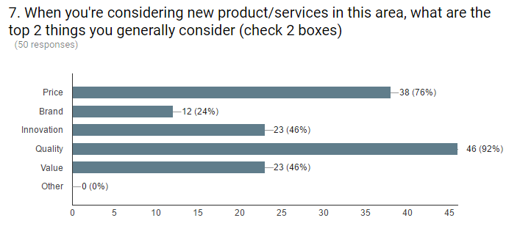

Based on the data above, the respondents have chosen quality as one of the top things one would consider for the service (92% have chosen this). While price has been chose 76% of the time.

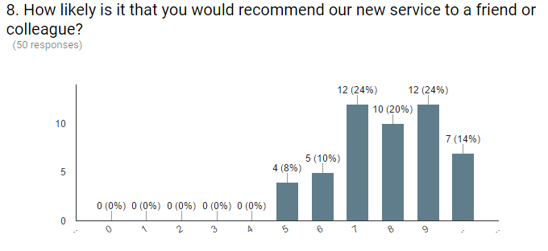

Based on the data above, the respondents have responded rather well. Nobody has rated a 4 or below. All the respondents have rated 5 and above, which is a positive output.